How to Compile a C++ Program Using EditPlus (in the OTS Labs)

- Open EditPlus. Look on the Desktop for 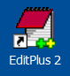, or use Start – All Programs – EditPlus 2 – EditPlus 2

- You should see something like this. The default directory on the left side may be different.
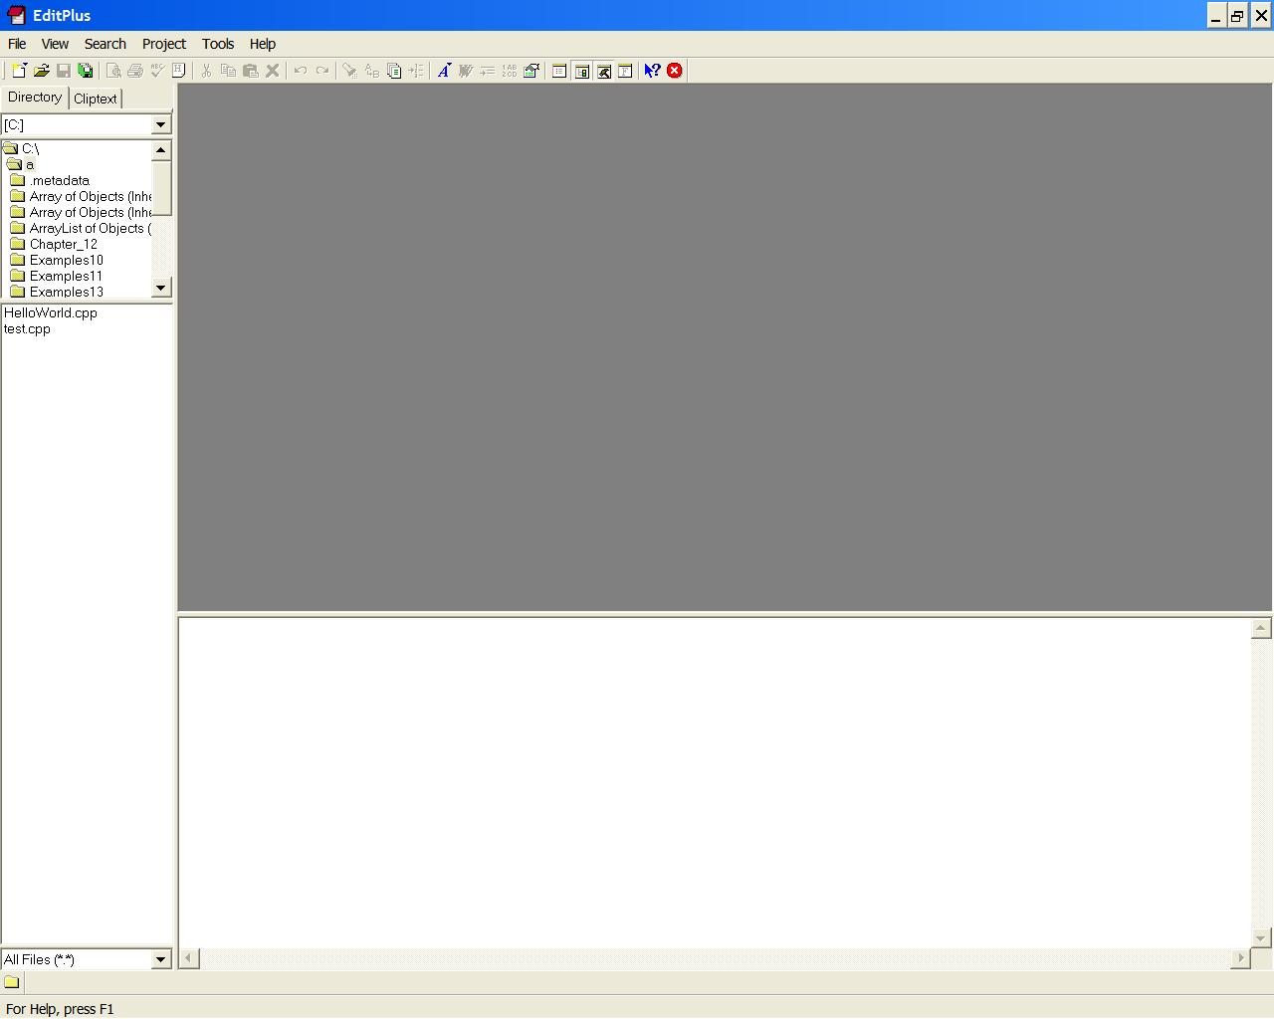

- To open your C++ program, either change the directory on the left side of the screen to point to your program directory and click on your program to open it, or use the “File-Open” drop down menu to locate the directory that your program is in and to open it.
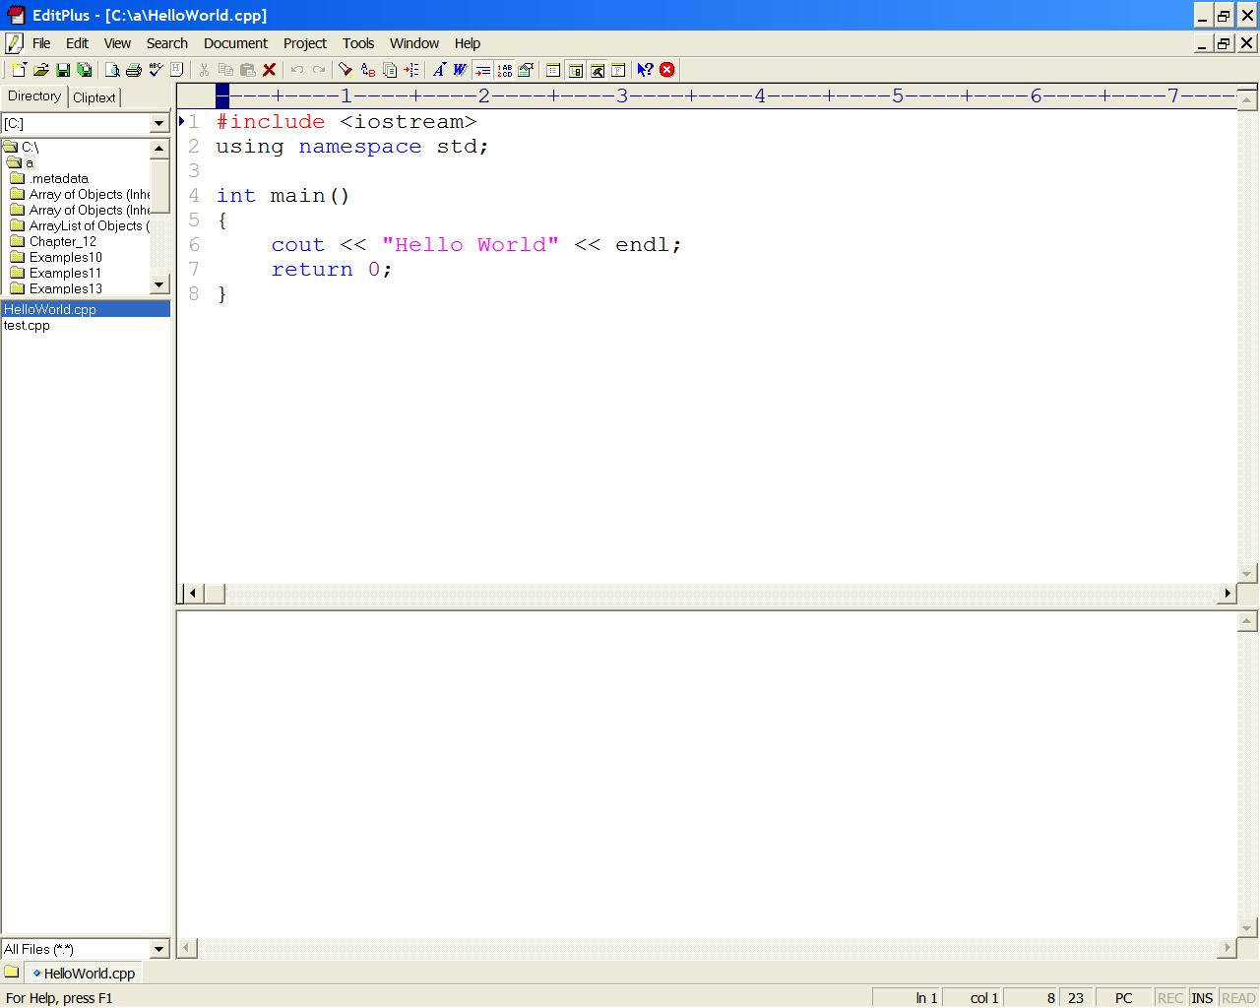
- To compile your program, under the “Tools” menu there should be a “Compile C++” option, choose it (your options may look slightly different).
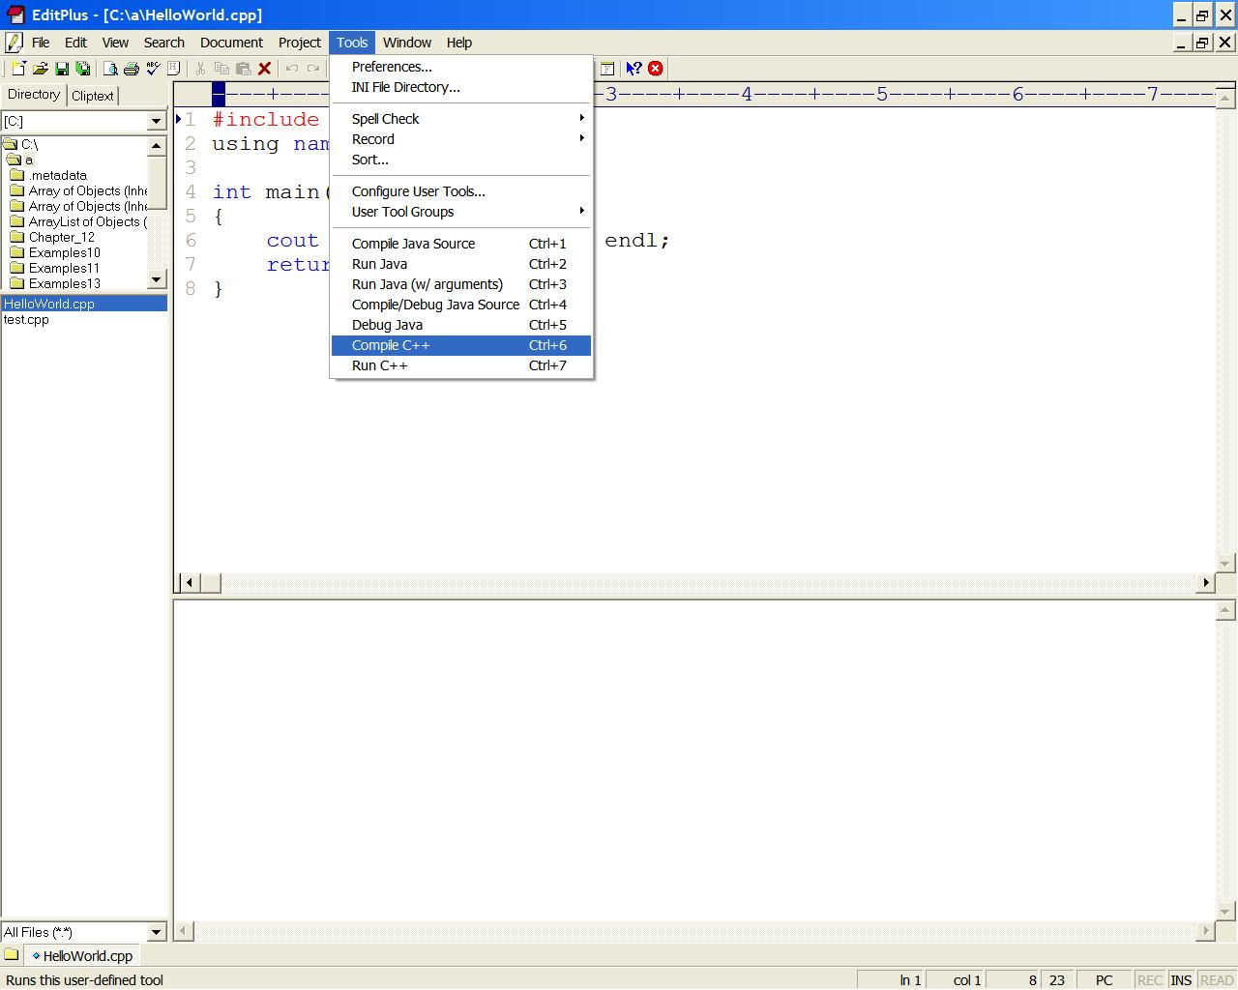

- Any compiler error messages will be shown at the bottom of the screen.
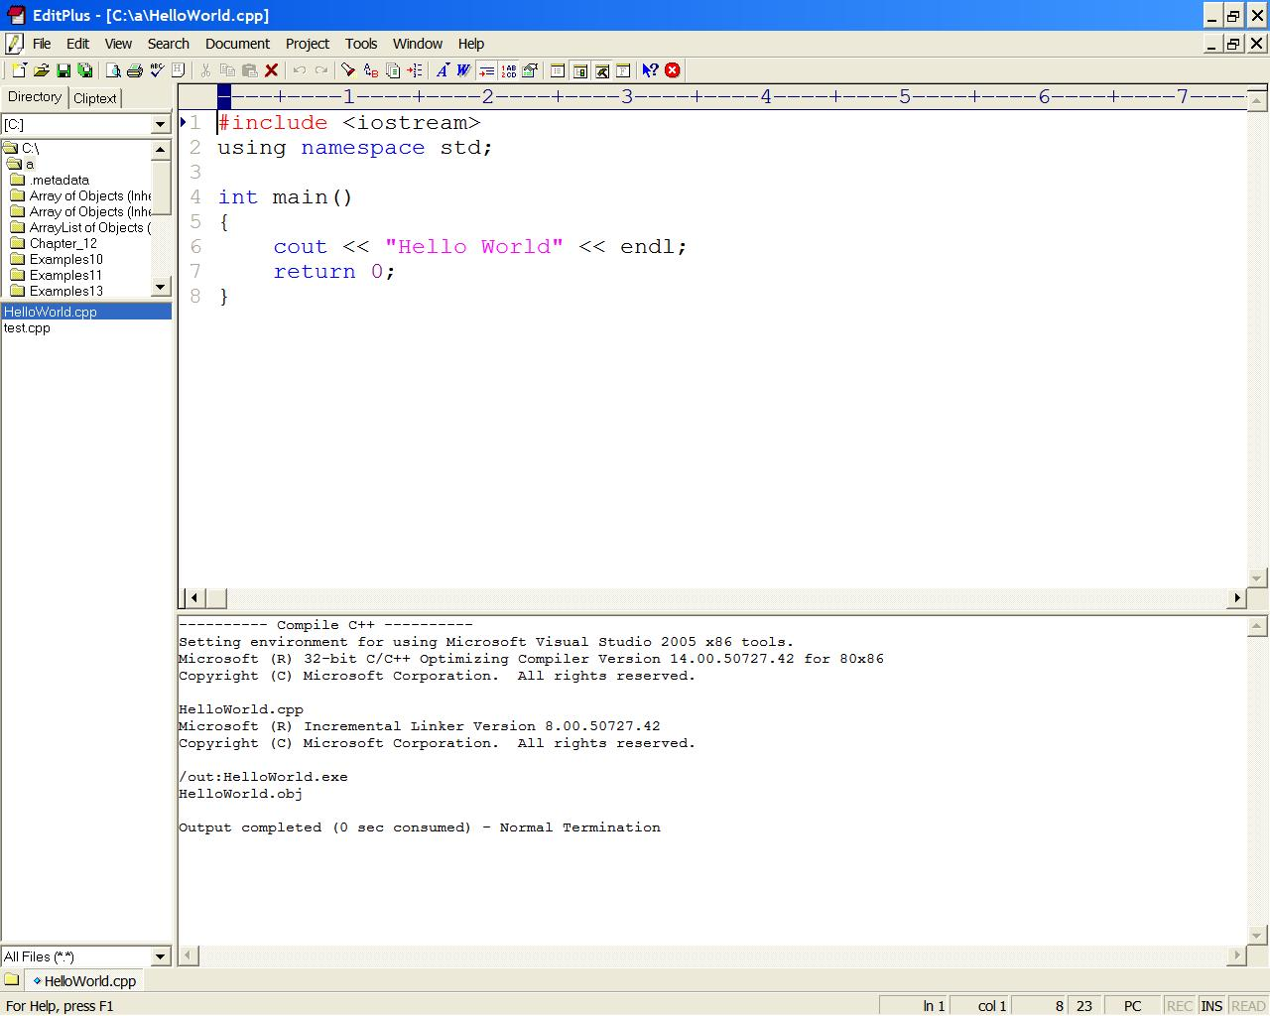

- If you have no compiler errors, you can run your program using the “Tools - Run C++” menu item.
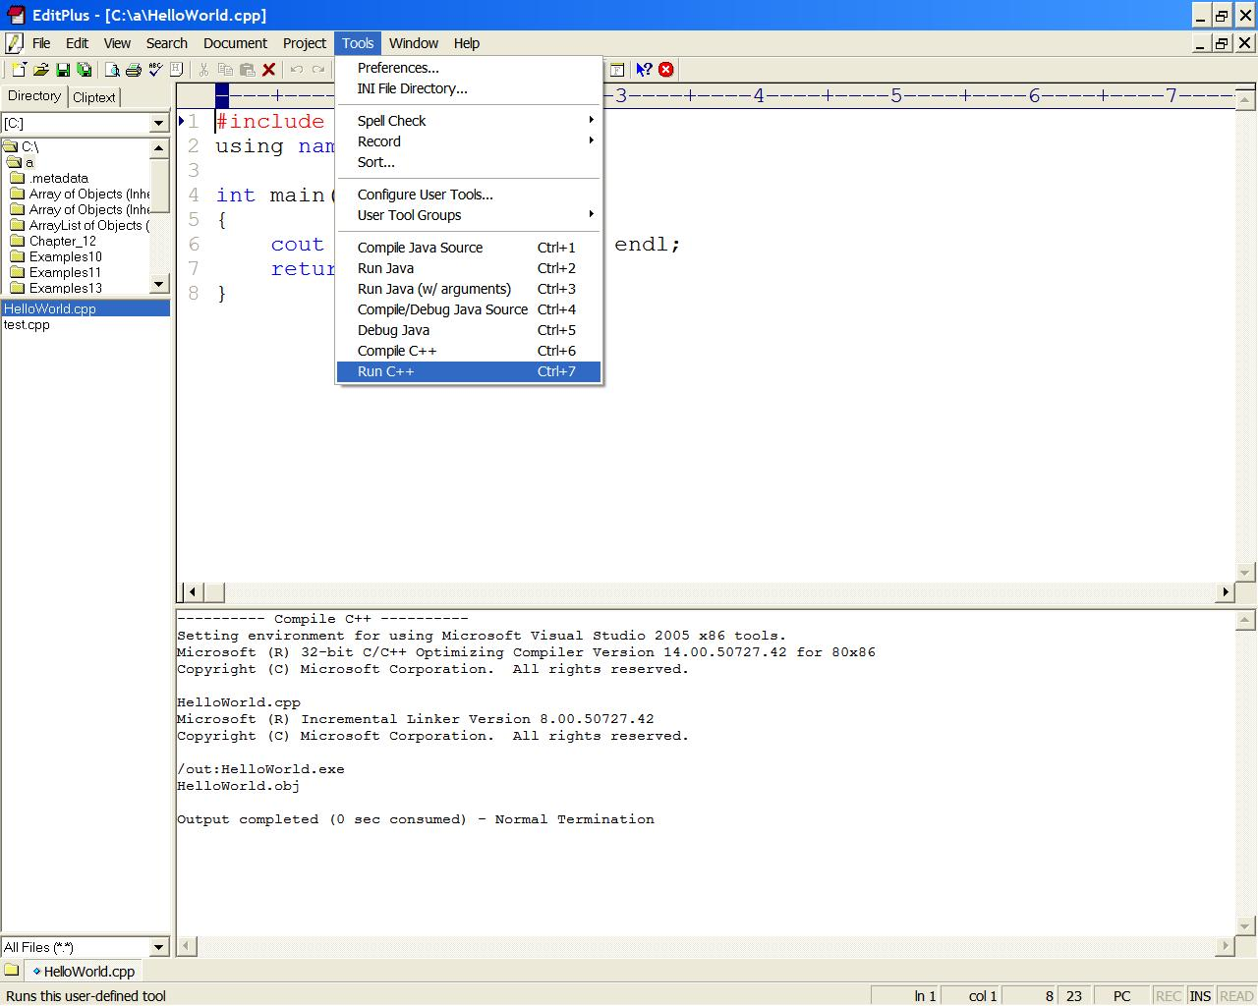
- A “DOS” window will open with your program running in it.
