GUI BUILDING USING NETBEANS (BASED ON 6.0 VERSION).
NEWER VERSIONS COULD BE USING SLIGHTLY DIFFERENT NAMES FOR VARIOUS MENUS AND OTHER ITEMS!!!
By George Koutsogiannakis
- Go to Menu File choose New Project
- In the new Frame opened select General and Java Application then press Next
- Enter the desired name for your project i.e. MortgageCalculator
- Choose the directory path where you want your project to be saved
- Deselect Create Main Class
- Press Finish and close the Frame

The NetBeans GUI looks as follows:

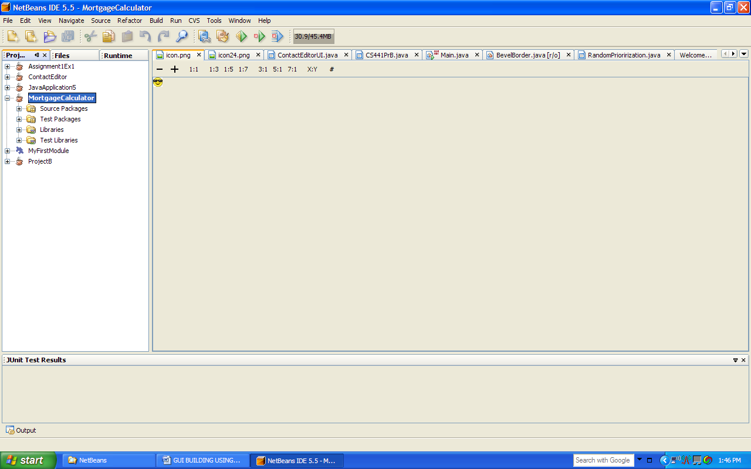

The left hand side lists all the projects under the Projects Tab . Notice that there are 3 tabs (Projects, Files and Runtime).

Right click on the project name you just created (i.e. MortgageCalculator) and select
New->New JFrame Form
On the Panel that opens up enter a name for the frame (i.e. MainFrame), and a package name (i.e myname.main). Click Finish.

Now you have :

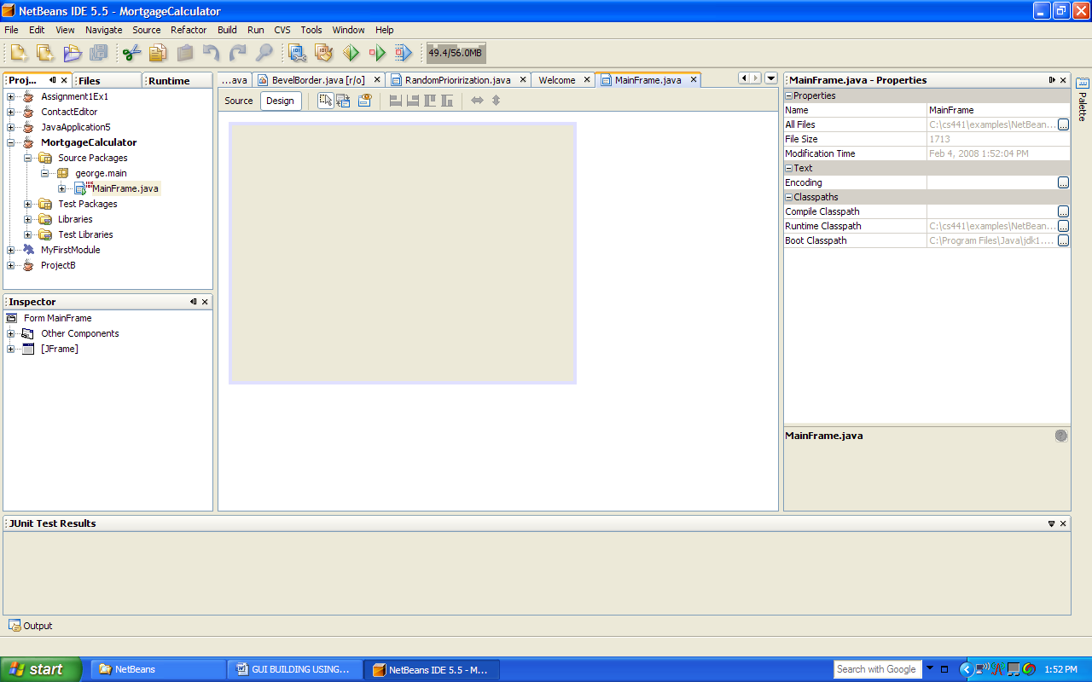

You should be in Design mode. The pane in the center is where you are going to drag and drop components. You get the components by clicking Palette icon on the extreme upper right. The pane to the right of the Frame you are building represents the properties of the component in focus (i.e. the JFrame itself is in focus right now).

You can view the source code by clicking Source instead of Design above the JFrame.
The source code files are also found where the project is saved in the src folder. So far only one file is created under the outer class name for example MainFrame (if that was the name you gave to the JFrame).
Let us try to recreate the Mortgage Calculator GUI whose GUi should look as follows:

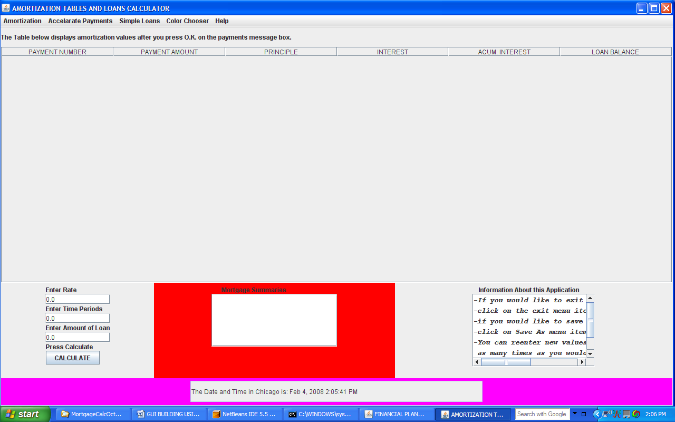

Drag and Drop a Menu Bar object at the top of the JFrame and 5 JPanel Objects a shown below: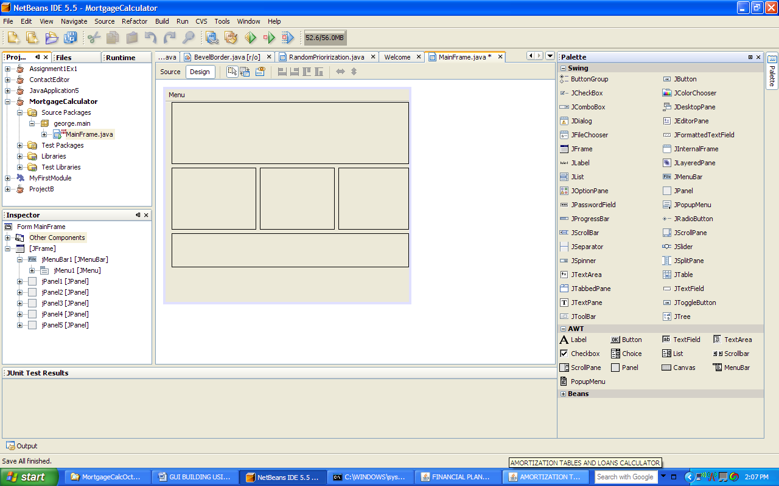

Now let us work on the Menu Bar.
- Click on the Menu label. On the properties area click on the text property. Type a new name: Amortization and save it.
- Go to the left bottom Pane Labeled “Inspector” The hierarchical tree of the components added so far is shown. Select jMenuBar1 and right click. Select Add JMenu. A new Menu is added to the menu bar under the name Menu. Change the name to Accelarate Payments and save it.
- Repeat steps 1 and 2 by adding 3 more menus: Simple Loans, Color Chooser and Help.
Now let us add menu items. We will add two menu items in the first Menu called Amortization as an example.

- In the Inspector Pane select jMenu1 and right click and select add->JMenuItem. Click text property and set the name of the menu item to “Save Amortization Table As”
- Repeat step 1 and set the name of the new menu item to “Exit”
Now let us add the event that would allow us to exit the program when the exit menu item is clicked.

In the Inspector Pane right click on the second menu item (Exit). Select
Events->action->actionPerformed
The source code is shown with a comment “add code here”. Add the code
System.exit(0);

Switch back to Design mode from Source.
In the Inspector Pane right click on the first menu item and select event->Action-actionPerformed. The source code is shown. Add manually the code for the JFileChooser.

Now add the JTextFields and their JLabel Components in the JPanel #2,as well as a JTextArea in JPanel # 3 and another JTextArea in JPanel # 4.

We would stop here as far as adding components. Save the project.
Under Build Menu select Build Main Project.
The system will compile.
Next under Run click Run main Project.
The system will ask you if you want the JFrame class to be your main class. Say OK.
The partially build GUI should appear on the screen.

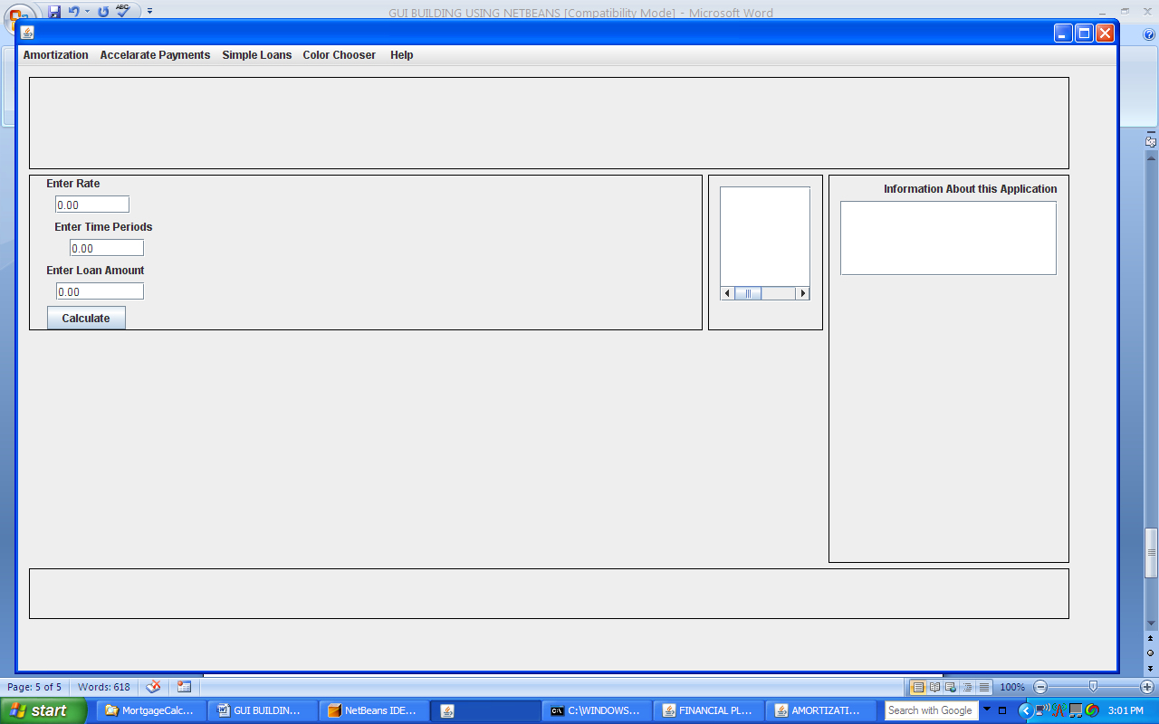

Click on the menu item Exit. The program should terminate.

Go to the folder where the source code file is located. You can manually add any additional code as needed.

Use Help as needed in order to understand how to add and set properties of components.
Notice that for the JComboBox in order to establish items you go to the model window of the JComboBox and select the item. Then edit its name to the desired name (or you can delete the preprinted items and then type a name and click add-repeat for as many items that you want to add).

